WATERDEEP PLACES OF INTEREST

TAVERNS/INNS

NAME | DESCRIPTION | NOTES | PERSONALITIES
The Grinning Lion | North Ward (N56) (tavern, C, 1)  Tucked away inside a block of homes and businesses, this place, adorned with battle trophies from all over Faerûn, is as raucous as taverns get in North Ward. | An old joke claims the Riven Shield Shop (T4) sends all shields beyond repair to hang on the walls here. The music is loud, with male and female dancers in fantastically styled and revealing mock armor swaying and pirouetting among the tables. Real, if broken, weapons hang on the walls everywhere, so bouncers swiftly discourage any disputes. Folk come here to drink zzar and wine and eat fried onions and eels. | The proprietor is Unger Farshal (male Tethyrian human) is bald, close-mouthed, and dangerous-looking.  A certain fat man on a stool at one end of the bar can help visitors buy and sell goods that are rather “warm”. He knows, tolerates, and says nothing of criminal activities in the ward (which keep him in profits).
The Jade Jug  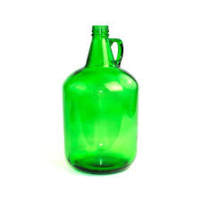 | Castle Ward (C38) (inn, B, 4)  The place for visiting nobility to stay, or for Waterdhavian nobles to stay while their villas are being rebuilt, repaired, or simply cleaned up after a particularly successful party. | Waterdeep’s most luxurious inn,  with rooms 12 gp to 30 gp/night and suites 25 gp to 50 gp/night. But, until you.ve been bathed by a cheerful, skillful, beautiful maid  who wears white gloves as she soaps you, you haven’t lived. | Amaratha Ruendarr (human female is the charming and beautiful proprietress. Amaratha runs the Jade Jug as the sort of place she’d like to stay in -and does, as a guest, when it’s not full. She has a perfect  memory and makes a point of learning the names and details that guests want to give her, so that she can take an interest in their doings and make them feel important on their next visit.

NAME | DESCRIPTION | NOTES | PERSONALITIES
The Yawning  Portal Inn  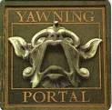 | Castle Ward (C48) (inn, C, 3)  Built atop the ruins of Halaster’s Hold. | The Yawning Portal inn (C48) contains the primary entrance into Undermountain, a large well that drops down into Undermountain’s first dungeon level  (UM L1).
Inn of the  Dripping Dagger  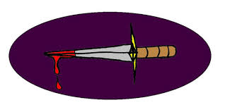 | Trades Ward (T3) (inn, B, 4)  This cozy old inn stands on the  east side of the High Road, south  of Selduth Street and north of the Coffinmarch. | The favorite watering hole and resting place for hireswords, and has a reputation for jovial horseplay that keeps the more timid merchants and pilgrims away from its doors. | The proprietor is Filiare (male Illuskan human), a jovial, middle-aged ex-mercenary who’s Blazidon One-Eye’s chief competitor in the business of getting mercenaries hired. He has been known to show kindness to adventurers and mercenaries down on their luck. He is also the father confessor to, and sometime intimate friend of, many unhappy noblewomen of Waterdeep.

NAME | DESCRIPTION | NOTES | PERSONALITIES
The Thirsty Sailor | Dock Ward (D12) (tavern, D, 3)  This infamous dive faces the Ship’s Prow across the intersection of Fish and Ship Streets | This ugly, poorly built tavern began as fieldstone with wooden upper levels, but many fires and wild brawls with magic as well as axes and hurled tables have changed its face. The interior of the Thirsty Sailor is no better than its battered exterior. | The proprietor is Kaeroven “Smiles” Yuluth, a tall, rotund, unpleasant-looking man with tiny deep-set eyes whose stare is as hard and cold as two dagger points.  He has blond, curly hair and is clean-shaven, with razor scars to prove it. His nickname comes from the fact that no one  has ever seen him smile save when he’s dragging the latest corpse to the rear of the tavern for disposal into the sewers.
Elfstone Tavern  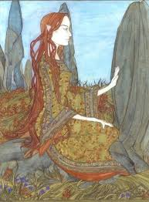 | Castle Ward (C32) (tavern, B, 2)  This old, dimly lit tavern stands on the east side of the Street of the Sword, north of Waterdeep Way. | It caters to elves and half-elves, and is an earthy-smelling place, where living trees have been encouraged through elven patience and forestry skill to grow up from the cellar and through the taprooms. | Yaereene Ilbaereth is the tavern's seeminglyunaging proprietress. She is a tall, charming and regal elven woman with silvery eyes, who goes about with a grinning faerie dragon perched delicately on her shoulder.  Tymaara Moonsmile (female half-moon elf), a waitress at the Elfstone Tavern.

FESTHALLS

NAME | DESCRIPTION | NOTES | PERSONALITIES
Mother Tathlorn’s House of Pleasure and Healing | Castle Ward (C43) (festhall, B, 5)  This is the most famous house of pleasure in Waterdeep, and that’s not surprising. It’s a large, five-floored building with two additional levels of dungeons below ground, in which absolutely no expense has been spared. | Mother Tathlorn.s has on staff several priests of Sune. In return for offerings to the goddess, they heal torn muscles and sprained limbs. Almost all of the rest of the staff are trained and capable masseuses. | The festhall’s prioprietress, Mother Tathlorn, is old and stout, but charming. She is skilled at massage and in reading the needs of a customer who is shy, drunk, or unfamiliar with the common tongue.
The Jade Dancer  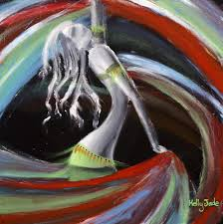 | South Ward (S15) (festhall, B, 3)  This raucous haunt of the young, free, and ardently romantic opens onto Dancing Court, sometime site of the eerily beautiful Moon Sphere, just north of Slop Street in the Tween Run (the local name for the alleys and buildings between the High Road and the Way of the Dragon). | The Dancer has a staff of expert, good-looking escorts who mingle with the patrons. Misguessing who is a patron and  who is an escort has left many a visitor to the city with a face red and ringing from a hard slap. The establishment is named for its star dancing attraction: Jade, a magically animated, incredibly beautiful, life-sized  jade statue, fashioned like a human female. | The proprietress of the Dancer is the seldom-seen sorceress Cathalishaera, who relies on her bouncer Selcharoon Nrim and her staff of about 20 female and 12 male escorts, about half of whom are on shift on a given night, and the house staff of 10 bar and kitchen workers.

NAME | DESCRIPTION | NOTES | PERSONALITIES
The Hanging Lantern  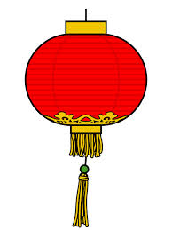 | Dock Ward (D22) (festhall, C, 6)  The Lantern, an escort service known for the stunning beauty of its workers, and for the skill of its matchmakers, is famous up and down the Sword Coast. | Folk come to the Lantern for just one purpose, slipping in any of its seven doors into small, intimate rooms.  Escorts can be had for as little as 10 gp for on-the-arm service only. If acting is involved, such as playing a false part in a conversation meant to be overheard or pretending to wealth or identity in business dealings, the minimum fee is 25 gp. If more is desired, fees rise from there to a high of around 75 gp. | Lady Cyrtue (female human), owner of the Hanging Lantern festhall.
Golden Horn Gambling House | Trades Ward (T28) (festhall, B, 3)  This ornately gilded palace of gleaming black polished marble stands on the east side of Snail Street. Red carpet, red sofas, red cushions, dancing girls wearing sheer red silk gowns (high cut and low cut!), and even a red-painted ceiling. | The lamplight is kept dim, I suspect, to hide as much of the cheating from the customers as possible. If any notice and object, the 16 bodyguards in the place converge like thirsty stirges, and the disturbance is quickly and quietly removed. | The Golden Horn’s proprietor, Hahstoz Baerhuld, is a dark, silent, expressionless man who seems to glide silently around the place.
PLACES OF WORSHIP

NAME | DESCRIPTION | NOTES | PERSONALITIES
Church of Gond  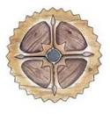 | Sea Ward ($38)  House of Inspired Hands  (temple, B, 3s) | Waterdeep has long been a bastion of enterprising artisans and craftsfolk, many of whom worship the Wonderbringer. Merchants from Lantan are believed to have first introduced the teachings of Gond to the settlement, and their teachings were in large part responsible for the ascendance of Waterdeep’s mercantile culture.  The Waterdhavian branch of the church has long benefited from the generous donations of Waterdeep’s prosperous tradesfolk. | High Seeker Jhoadil Zulthind: (female Lantanna human) is a plump, green-eyed, copper-haired woman, with the characteristic parchment-colored skin of her ancestors. She projects the amiable—almost grandmotherly— air of someone is a tinkerer with little ambition
Church of Mystra  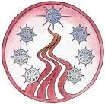 | Sea Ward ($21)  House of Wonder (temple, A, 5s) | Waterdeep has a strong tradition of both wizardry and sorcery. Waterdeep’s Mystran  church is closely allied with the Church of  Selûne, and the two faiths work together to  battle the followers of Shar. | Meleghost Starseer: Magister of Mystra Meleghost (male Chondathan) is the  cruel, urbane master of the House of Wonder. He has long, slender fingers, a shaven head, and a neatly trimmed goatee.  Ilbrost Mythyl: Ilbrost (male Tethyrian human) is an aging enchanter who deftly relies on his magic to maintain his prominent social position. Ilbrost is always immaculately groomed, with a wandthin mustache, sumptuous wizardly robes, and slicked-back, thinning gray hair.

NAME | DESCRIPTION | NOTES | PERSONALITIES
Church of Tyr  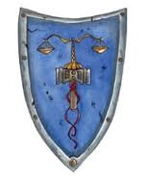 | Castle Ward (C5)  Halls of Justice (temple, C, 5) | Waterdeep has long been a bastion of justice and the rule of law in the North (or at least has aspired to be such), thanks in large part to the followers of Tyr who have long played an illustrious role in the governance of the City of Splendors.  . | Hykros Allumen: Hammer Lord Hykros (male Illuskan) is the high priest of the Halls of Justice (C5) and the leader of the clergy of Tyr in Waterdeep. Hykros is a devout worshiper of the Maimed God and a strong pillar in the defense of the rule of law in Waterdeep.
Church of Tymora  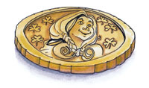 | Sea Ward ($19)  The Tower of Luck  (temple, A, 2s & 3s) | The City of Splendors has long been a beacon for adventurers who trust their lives to Lady Luck. The donations of those who braved the depths of Undermountain and survived to tell the tale alone were enough to construct the Tower of Luck in just a few short years. | Honorable Mistress Seenroas Halvinhar  (female Illuskan).  Adama Miiralin: Adama (male Chondathan human) is a naïve, kindly young priest from Arabel with aspirations of rising up in a temple hierarchy far from the heresies of his native church.

NAME | DESCRIPTION | NOTES | PERSONALITIES
Church of Shar | Vanrakdoom (UM SLM)  From their Undermountain base, the church of Shar grew strong, exerting its influence throughout much of Undermountain itself and periodically dispatching assassins and marauders to battle followers of the Moonmaiden in the city above. | Vanrak Moonstar: Lord Vanrak (male Tethyrian human), the Dark Ranger, has long been the bogeyman of House Moonstar and the Church of Selûne, residing in the depths of Undermountain as the master of Vanrakdoom (UM SLM). | Gathgaer Milomynt: Gathgaer (male Chondathan human) is a beak-nosed, alert-looking man with close-cropped brown hair and beady brown eyes. He favors dark robes and a handy mace at his belt. Gathgaer is a medicinal healer, selling medicines and treatments out of a run-down house in Dock Ward (D68).
Church of Umberlee  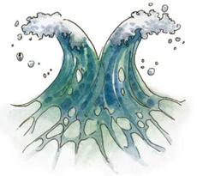 | The Queenspire (H5)  Dread High Trident Meritid Archneie discovered a magic abalone shell floating in the harbor, which he believed to be the legendary Orglara, a sacred text of the Bitch Queen. | Seeing this as a good omen, Meritid promptly petitioned the Lords to use half the annual tithe to construct a temple to the Bitch Queen atop a large outcropping of rock near the end of the large sandbar that extends south of the city’s South Gate. Without explanation, the Lords agreed to his unlikely request, and construction was begun on the azurehued  Queenspire. | Dread High Trident Meritid Archneie (male Tethyrian human).
PERVAYORS OF MAGIC

NAME | DESCRIPTION | NOTES | PERSONALITIES
Thayan Traders Enclave  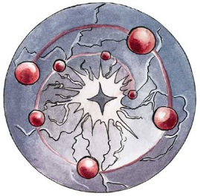 | Lower Heart district of Skullport (C70).  When Rose Keep Enclave is open for business, the courtyard is crowded:  A large red tent squats in the center of the courtyard. Its drawn flaps reveal a large wooden table on which glass vials, scroll cases, and other oddments are gathered. A woman in a red caftan minds the table. Outside the tent, several human guards and their eladrin captain watch the proceedings. | The Thayans sell all manner of imported items, but discounted magic items are their most popular merchandise.  Offer the standard 10% Thayan discount on magic items that can be ordered from the Thayan Enclaves (3,000 gp or less in value). Offer to buy magic items at the standard 50% rate.  For each magic item purchased, buyer is given a bronze token. Bronze tokens can be exchanged for a free 0-level arcane or divine scroll. | Tharna Shavres,  This elderly woman is gaunt with age, but her white hair remains full and is pulled back into a long braid. She is adorned with a variety of charms and amulets, wields an impressive staff, and wears a complex layering of red cloaks that appear to move and swirl of their own accord.  Dorim Cragwatcher,  This regal-looking dwarf wears a grand robe of scarlet under a striking blue cloak. His beard is clasped in arcane strictures, and a great winged bat perches on his shoulder as if a pet bird of prey.  Vanargen the Astronomer,  This gaunt-looking human male wears a red leather greatcoat without sleeves. The man’s arms are tattooed with stars and strange constellations.
Aurora’s Realms Shop | Castle Ward (C37) (business, C, 1)  For those unfamiliar with Aurora's Realms Shop, Aurora, a retired adventurer, has created the finest shopping experience in Faerûn via her catalog and conveniently located outlet stores. | Outlets of this popular Realms-wide retail chain are in each ward of the city (Sea Ward, North Ward, Trades Ward, Dock Ward, South Ward). This makes for minimal delay and uncertainty when emergency purchases must be made, and results in goods of known quality. | Xanatrar (human male, a service mage of the shop, is also known for his excellent singing at parties and whenever he wants to impress a good-looking lady. He is a regular at nobles’ feasts.

NAME | DESCRIPTION | NOTES | PERSONALITIES
Balthorr’s Rare and Wondrous Treasures | Castle Ward (C14) (business, C, 1)  Balthorr owns Balthorr’s Rare and Wondrous Treasures offering a wide selection of curios. | Balthorr’s apparent honesty is belied by his willingness to purchase coins, gems, and  regalia with no questions asked, although if he suspects an item is “hot” he offers only 40% of market value. | Balthorr “the Bold” (male Tethyrian) is a hearty, loud-voiced, bubbling fellow with a ready smile and firm handshake. He is an expert on the currency, uniforms, and badges used by most realms of Faerûn, and he can make up colorful stories about the history of particular items on the spot.
Halaster’s Heirs  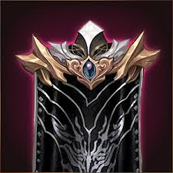 | Level 1 of Undermountain, (UM L1)  Vicinity of the Yawning Portal.
SHOPS

NAME | DESCRIPTION | NOTES | PERSONALITIES
Saern’s Fine Swords  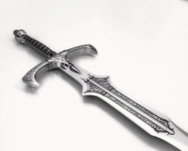 | Trades Ward (T7) (business, B, 2)  This shop stands on the south-eastern corner of the meeting of the High Road and Burnt Wagon Way. It’s an old, massively built stone place with bars on all the windows, crenelations on the flagstone roof, and a narrow exposed, iron-bound door overlooked by arrow slits.in short, a miniature fortress. | It holds a large stock of swords, including a few made by Szwarharba the Swordsmith, the famous craftsman of Tethyr. The shop has at least three staff on duty at all times, one of whom is an out of- uniform city guard officer, who notes the names and descriptions of those who buy particular weapons. | Zygarth “Slayer” Saern (human male) is the proprietor of Saern’s Fine Swords. He has acquired the ability to determine with 96% accuracy the age, quality, and condition of steel at a glance. He is 76% likely to realize that a blade carries a magical dweomer merely by looking at it. He is tall, gaunt, smiling, and unassuming. Few know he is a warrior, as his nickname was bestowed by a noble in jest.
Riven Shield Shop  - 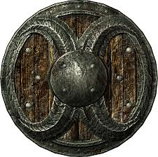 | Trades Ward (T4) (business, B, 2)  This store not only hold shields as the name implies but also has weapons, from slender blades preferred by noble ladies to the heavy broadswords favoured by barbarians. | An old joke claims the Riven Shield Shop (T4) sends all shields beyond repair to hang on the walls of The Grinning Lion (N56). No one is tempted to steal the more valuable pieces. It is widely known that some of the magical shields hanging from the rafter beams contain magically imprisoned monsters that can be released to fight. It is also well known that one of the items in the shop (no one is quite sure  which one, and the proprietor neglects to say) is an alert, always vigilant, sentinel. | Delborggan the Blade (human male) is a grizzled, one-eyed ex-adventurer. He is a man driven to adventuring by grief (as he says, “For it is an ill thing -a heavy thing- for a boy to be not loved by his father”), who now views the world with buoyant, if cynical, good humour. As the proprietor of the Riven Shield Shop, he’s always armed with magic items, including (under his eye-patch) a waiting magical eye-cusp that can spout beams of fire when he desires.

NAME | DESCRIPTION | NOTES | PERSONALITIES
Halls of Hilmer, Master Armorer  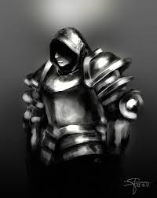 | Castle Ward (C23) (business, C, 1)  This shining shop has a front of  armor plate -old armor from  vanquished foes of Waterdeep | Inside is a showroom and fitting room, with doors into a weapons practice room for clients to practice running, turning, fighting, and climbing stairs in armor, and the huge, cluttered workshops of Hilmer and his apprentices. Plate armor hangs -or, in the form of full suits, stands everywhere. | Hilmer (human male) is a master armorer and proprietor of his own shop in Castle Ward. Although he is now retired, as an adventurer he was known to have explored Myth Drannor and much of Undermountain. He is tall with broad shoulders. He is known to be just, honest, and soft-spoken.
Red Sails Warehouse  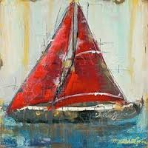 | Dock Ward (D20) (warehouse, C, 2)  This warehouse offers rental space to all, no questions asked. Material to be stored can’t be alive or flammable. | Space is 1 cp/day per longbox. The longboxes are more or less coffin sized. Empty cubicles of up to two longboxes deep and eight high are available multiply the fee accordingly. If cooling is needed,  ice and watching costs an extra 2 cp/day per longbox. | Orblaer Thrommox (human male) is the proprietor, is fat, strong and wears a full beard.

ORGANIZATIONS

NAME | DESCRIPTION | NOTES | PERSONALITIES
Company of Thayan Traders  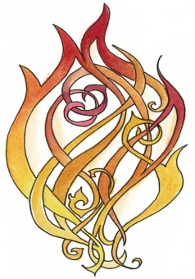 | Caravan lead by Chathi Chathendum- female human Wizard-Evoker/Red Wizard. | They travel to all the great Thayan Enclaves around Faerun, carrying with them items of power and also information from across the Realm. | Chathi has with her the rest of her company, Hoth Anskuld - male human Fighter/Thayan Knight,  Jandar Hahpet - male human Rogue/Wizard/Ranger, Kulara Tolman - female human Monk/Cleric.
The Knights of the Shield | The Knights of the Shield are consortium of merchants and nobles interested in manipulating political and mercantile activity for their own economic gain. | Based primarily in Amn, Tethyr, and  Baldur’s Gate, their influence extends from Calimshan and the Shining Sea to Waterdeep. The Knights have kept a low profile in Waterdeep for the past decade, after a disastrous attempt to overthrow the Lords resulted in the organization being largely driven from the City of Splendors. | Bly Ruldegost: The only Knight of any prominence to reside in the city is Lord Bly Ruldegost (male Illuskan human), a proud and honorable man and the regent of House Ruldegost.  Mather Ukkhemn (male Tethyrian) is a fat, egotistical Tethyrian merchant and visits Waterdeep on occasion for business.

NAME | DESCRIPTION | NOTES | PERSONALITIES
Agents of the Eye  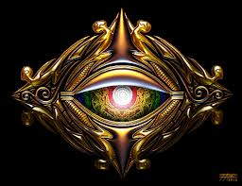 | The Xanathar Thieves’ Guild maintains scattered “safe houses” throughout the sewers of Waterdeep.  In Undermountain, the Agents of the Eye maintain a base in Skullport, the former residence of Misker the Pirate Tyrant, and control much of the Sargauth Level (UM L3). | The Xanathar, also known as the Eye, is Waterdeep’s most powerful and successful beholder. The Eye is served by a large group of agents, known in Undermountain as the Agents of the Eye and in Waterdeep as the Xanathar Thieves’ Guild. By either name, the Xanathar’s operation controls a large fraction of Waterdeep’s slave trade and is rivaled only by the Shadow Thieves in its dominance of petty thieving operations in the City of Splendors.
Shadow Thieves  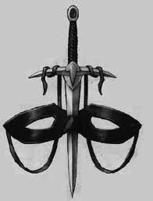 | The Shadow Thieves of Waterdeep are based in a half-dozen safe houses scattered through Dock Ward, Southern Ward, and Trades Ward. | Founded over a century ago in the City of Splendors, the Shadow Thieves were eventually unmasked and nearly destroyed by the Lords of Waterdeep.  Before their banishment, the Shadow Thieves were based in the Citadel of Bloody Shadows in the heart of Mount Waterdeep.

NAME | DESCRIPTION | NOTES | PERSONALITIES
Red Sashes  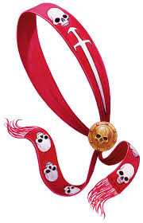 | Various taverns in Dock Ward.  The Red Sashes are a vigilante group active in Waterdeep’s poorer neighborhoods, particularly Dock Ward. | Answering only to “the One”, the Red Sashes excel at intrigue, hiding people, and finding people who do not want to be found.
The Gray Hands  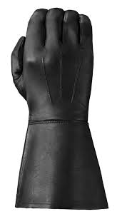 | Castle Ward (C6)  Blackstaff Tower  (wizard’s domicile, B, 4)  Although Waterdeep is ably defended by the City Guard and City Watch, some threats require more extreme solutions. | The Gray Hands are an elite force of high-powered adventurers who answer directly to the Lords of Waterdeep. Although their numbers are small, members of this group are capable of confronting the most powerful foes.  The Lords of Waterdeep are loath to call on the Gray Hands unless no other option prevents itself, for the fallout from conflicts involving this group inevitably inflict a great deal of collateral damage on the City of Splendors.

NAME | DESCRIPTION | NOTES | PERSONALITIES
City Watch  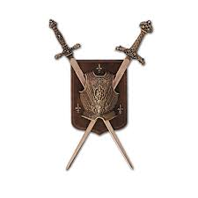 | Piergeiron’s Palace  Castle Ward (C76)  A watch street patrol consists of four members: a civilar (captain or lieutenant), an armar (sergeant), and two watchmen or watchwomen. | The City Watch serves as Waterdeep’s police force, patrolling the city and ensuring the well-being of its inhabitants.  In addition to arresting those who break the laws, Watch patrols often assist passersby with heavy loads, give directions, search for lost children, provide basic medical aid, and referee verbal disputes. | The commander of the Watch is Captain Rulathon, who reports to Piergeiron.  His senior commanders are Grand Civilar  Derek Windsfire (male half-moon elf), Mage Civilar Thyriellentha, and Senior Armsmaster Helve Urtrace.
City Navy  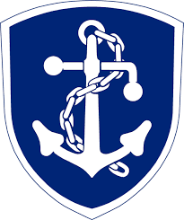 | Inner Fort (H4), Outer Fort (H3), Smugglers’ Bane Tower (H1), and  Harborwatch Tower (H2),  The navy’s fleet consists of 16 fast “rakers” (or dromonds), slim top-armored vessels usually armed with two fire-pot light catapults and two large deck-mounted ballistae that the guard uses with stunning accuracy against pirates and smugglers.  They are supported by twenty-four small lateen-sailed galleys, known as “strikers,” and fifteen large, wallowing troop-and-supply vessels, or “transports.” | Heavily reliant on maritime trade, Waterdeep has long maintained a powerful navy capable of dominating its rivals  along the Sword Coast and protecting its merchant shipping from pirates and monstrous threats.  The navy’s fleet is based in the Naval Harbor. | The commander of the Nany is Admiral Helkar Hornwynd (maleIlluskan).

NAME | DESCRIPTION | NOTES | PERSONALITIES
City Guard  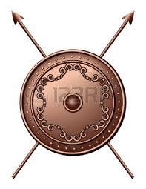 | Castle Waterdeep (C76), Guard Armory (C47), Guard Barracks (C19, D56, N1), Palace (C75)  A Guard patrol consists of twelve members: a civiler (captain or lieutenant), an armar (sergeant), and ten Guardsmen or Guardswomen. | The City Guard serves as Waterdeep’s army, defending the City of Splendors from attack and patrolling the surrounding countryside.  The Guard also serves as bodyguards for Piergeiron and as honor guards for visiting diplomats.  Contingents of the Guard and the Watch jointly man the city gates; the Guard controls access, while the Watch observes those who enter, pursues fugitives, and escorts visitors into the city | General Obryn Ironfist, son of Arnn, blood of Turgo, of the Forlorn Hills of Dardath (male shield dwarf).  Madeiron Sunderstone (male Illuskan human) stands an astonishing eight feet tall in height.
Griffon Cavalry  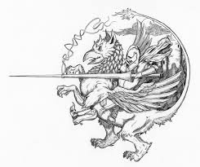 | Peaktop Aerie (C67)  A griffon-rider patrol consists of four griffon-riders and their mounts. They include a civilar (captain or lieutenant), an armar (sergeant), and two regular griffon-riders. | Waterdeep’s griffon-riders patrol high above the skies of Waterdeep, defending Mount Waterdeep and the city below against intrusion.  The Griffon Calvary is an elite company of the City Guard, and its leader, Lord Moedt, reports directly to General Obryn Ironfist. | The commander is Lord Moedt Belabranta (male Tethyrian  human).

OTHER

NAME | DESCRIPTION | NOTES | PERSONALITIES
Anchorage Haven  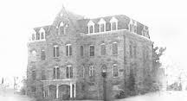 | Orphanage near the temple of Gond. Currently holds about 24 orphans. | The church helps them out with clothes and food, but it is still pretty run down. They do not have much in books/toys/schooling. | Anchorage Haven seems to be managed by a cleric of Gond by the name of Willamer Barnabas.

