Chapter 29 – Deep Dragons, Spiders, Driders, and Dead Dwarfs

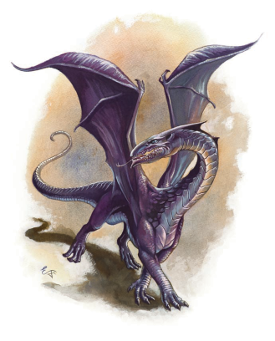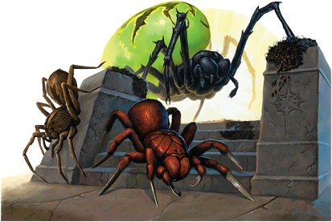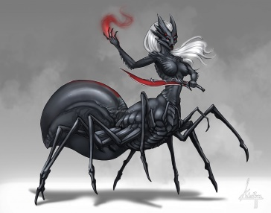

The ‘night’ passed uneventfully. There had been no intrusions during their watches; nothing to set off the magical alarms. Arising, after ablutions and a quick breakfast, they set off.

Lord No’s Note-For obvious reasons there is no ‘day’ or ‘night’ in the Underdark. Those who need to measure time do so by either mechanical means, magical means, or some combination.

For several hours they travelled; the only illumination being the pale blues and greens of bioluminescent fungus and algae proliferating on walls, floors, and ceilings. By ‘mid-morning’ the fungal growth became sparser diminishing the light. Eventually the passage opened into a large grotto. Here the radiance was at its lowest. The space filled with shadows. Beyond, one could see two passageways leading out with the light increasing.
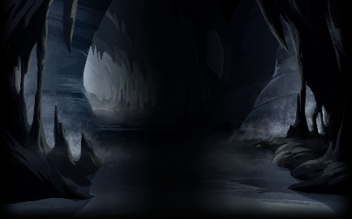

Gwenect halted them. “Be alert here. These shadowy hollows are good hiding places for all sorts of nasties. We go left.” She led them across.

Trailing, as a rearguard, Dark Swan was halfway across when, as happens inevitably in the Underdark, the creature struck.

It flowed from the shadows, as a shadow itself. A child of shadows, not a drop of colour tainted the all-ink black gigantic spider. Waiting for the last in line, it lunged out, huge, serrated mandibles snapping to sever bodies and limbs.
But this was the Dark Swan. Her embracement of the Dark made her ‘shadow-sensitive’. She noticed the infinitesimal shift of the shadows and was already tumbling away, an instant before the spider jaws clanged together to where her neck had been.

Granpar’s bow, was not just a weapon, but more of an extension of her body. Tumbling, she released arrows, each one striking deep and true.

The others reacted to the commotion.; Kilzadi first. Streaking from his palm, a quickened tiny ball of fire, leading a ray of flame. Striking the spider, it erupted into a fierce fireball. The explosion’s red flash, for a few instants, lit up the entire cavern.

The spider reared and squealed. The dense unpleasant odor of burned arachnid filled their noses.

The beast, still fixated on its prey, ignored its injuries. It rushed at Dark Swan, who’s next four rapidly shot arrows, damaged it severely enough to halt its charge. This allowed Gwenect’s searing ray to burn through its head. The spider’s legs collapsed as it died.

In less than a minute it was all over, “Swan?”, both Risca and Okul questioned in unison.

“I am fine. It did not touch us. Let us not waste any more time. Continue.”

“If she is fine, then she is correct. Let us move along. Now quickly!” was Gwenect’s response.

They kept going, hearing scavengers, already feasting on the spider corpse.

“Another one of the Underdark super-predators, like those umber hulks and purple worms?” Neon questioned Gwenect as he trotted beside her. The others, spacing themselves out, had paired up behind them.

“Yes. A shadow spider. They lurk in poorly illuminated spaces, spaces that are filled with shadows, so they blend right in. Extremely difficult to detect. Then they spring out to ambush. Their smallest bite injects an horrific paralyzing poison and their mandibles have been known to bite into the hardest metals. Fortunately, Cygni was able to evade it.”

“About that. I have seen her uncannily dodge danger before, but this quick response was novel, different. The Swan I knew would not have been able to do that.”

“As I told Kilzadi when we rested, something about Cygni has changed. I also said that if she did not become a hindrance, we just continue. The mission comes first. Be glad she is still with us.”

“Oh, I am. I agree. First the mission. Then we investigate.”

“Okul, some power keeps sending us bugs, bugs, and more bugs. All sorts of bugs, all the time” commented Risca. The way the gurl handled that bug was awesome but it is not her. I share your worry. We will both keep a watch on her.”

“Yes, we will” was the curt response.

“Now you believe me?” Kilzadi questioned Gideon.

“I was first suspicious about her odd behavior back at the Pillar of Fire”, the priest answered. “Then I became too involved with my own matters to follow up. But yes, recalling events and watching her now, there is something amiss with Swan. And I concur. We will just have to watch her carefully.”

Fang had dropped back to pace alongside She of the Weyr. He had overheard the others. He did not share their unease. He approved of the new and relentless She of the Weyr. The Weyr was now better protected. Had she also overheard? If she did, there was no indication. Besides, no one asked for his opinion. So, he gave it no further thought.
------------------------------------------------------------------------------------------------------------------
They kept moving, stopping for a short rest and quick rations. Again, there was no bantering from the Seeker scout. This just confirmed to the rest that their fears were founded.

By ‘early afternoon’ the passage led them to a large valley. The ceiling now rose 100 feet above their heads, the floor dipped several hundred feet to the valley bottom where a small river rolled, fed by six coloured streams flowing gently down the valley sides.

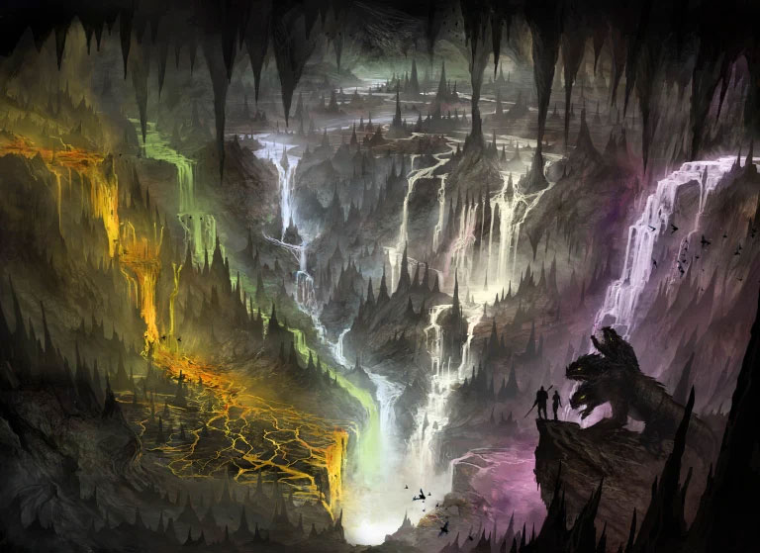

The passage they sought continued on the far side; half a mile distant. “No time for marvelling” commented Gwenect. “It is more dangerous to go down into and then up out of this valley. We take the longer and safer path and go around the top.”

“You know the Underdark best” replied Gideon. “We will follow your lead.”

“Silly surface-dwellers, all paths in the Underdark are dangerous.”

The voice now speaking was bass and guttural, the words loud and severe. It emanated from a large ledge near the top of the ceiling above their heads. At first, nothing could be seen, then, in a blink, a pair of dragon eyes appeared, a pale purple surrounding the black vertical pupils. Then it moved so that its slender serpentine head, covered in dark-purple-black scales became visible in the dim light.

It continued to speak as it regarded them. “Surface-dwellers. Good. Males, your magic and abilities will serve only me as I se fit. Females, you will be used to breed my half-dragon children. Your existence as my devoted slaves begins now.” It opened its mouth and breathed.

The dragon’s breath weapon was not an energy type. Nor was it sleep, slow, darkness, life draining, radiance, or blasts of material like sand, steam or ice. More dangerous and potent than any of those, it was an invisible cone, one of physic waves of domination, exclusive to deep dragons.

Lord No’s Note-Deep dragons are a rare breed unique to the Underdark. In darkness, due to their coloration, they can be mistaken for shadow dragons or even black dragons. In some light the differences become evident, as they lack horns or spikes, wings smaller, their bodies more lithe, slender, more serpentine, to allow for easier travel in smaller Underdark passages. Their scales are more the color of amethysts which gives them the nom ‘purple dragons’. Scholars, however, refuse to use this term as it causes confusion with true amethyst dragons and the even more extremely rare red-blue dragon hybrids whose colouration is usually some shade of purple.
Scholars also claim that deep dragons are the most intelligent of the chromatic dragons. Their breath weapon forces victims to be dominated by the dragon’s will. Repeated uses of the domination breath keeps lowering resistance of the entranced, until finally they lack will of their own and become devoted slaves.
Deep dragons are known to dominate the leaders of Underdark races as to rule through them. Dominated surface dwellers are usually used as informants, infiltrators, raiders
and to kidnap others for domination. They have a particular fondness for breeding humanoid half-dragons and then dominating them before they reach maturity to use as elite subordinates.
………………………………………………………………………………………….

The Seekers were not idle. They had faced down dragons before; red Volcanix, black Despayr, blue Enthranos. They were hardened against dragon-fear. As the dragon spoke, they were in action.

The domination cone swept through the group. Neon had already managed to tumble away and hide. He fixed the target for his bow.

Dark Swan’s ring, commissioned using the dual castings of Watchful Sister Alena and Noristuor the Mage, vibrated. It was designed to protect her mind for just such instances. The domination waves bent around her as an obstacle bends a current. She touched the amber amulet and commanded “vinite!”

Risca raged. Rage cemented his mind, fixed it solely on the desire and will to crush the enemy. There were no openings for an exterior will to grab hold. The domination waves simply slid off; water running off rock.

For Gideon and Gwenect’s their faith succored them. Such trust and devotion to their deities made their wills impervious to alien takeover. The domination waves just passed through their minds, moving through mist. This gave them time to prepare their spells.

On his paternal side, Okul was descended from a long line of gold dragons; gold dragons whose powerful wills he inherited. Shaking his head, he shook off the domination waves in the manner that a dog shakes off water. He drew out his javelins.

Fang happened to be outside the cone of domination. His weyr and Master were under attack. Roaring out a combat challenge, bolstering himself with a shield spell, he flew up intent on ripping out those purple eyes.

Kilzadi would have been the first to react upon seeing those purple eyes. Yet, before he could respond, his world went white.
‘’’’’’’’’’’’’’’’’’’’’’’’’’’’’’’’’’’’’’’’’’’’’’’’’’’’’’’’’’’’’’’’’’’’’’’’’’’’’’’’’’’’’’’’’’’’’’’’’’’’’’’’’’’’’’’’
INTERLUDE-Kilzadi and Fang were returning to the Eilistraee drow encampment.

“You fought well against those Red Wizard lackeys” the mage addressed the dragon. Always remember to spell shield yourself. Use the maneuvers we practiced.”

From behind, a voice interrupted, “Kilzadi Litecaster. A few moments of your time.”

Surprised at the recognition and rationality of the voice unusually rational, he turned to face Noristuor the tiefling mage.

“Yes, Noristuor, how…are… you,… and… what… can,,, I… help… you… with?” He spoke each word slowly as to not confuse the slow thinking mage.

The unexpected response rocked him..

“Kind of you, but nothing really. It is more of what I can do for you. And please, shall we not converse as adults? I have something for you. Will you accept it?”

Then he addressed Fang. “Well, greetings to you as well, Minionkilzadius. I am afraid I have nothing for you right now, but your gift is on its way. It will take, oh, about 500 years, give or take, to arrive. She and you will get along famously, well actually more that famously. But for now, here, have a cupcake,” So saying, he tossed one into the dragon’s mouth. Fang instinctively swallowed it.

Kilzadi, could access a situation quickly and act accordingly. But he could only shake his head in Noristuor acting so out of character. Attempting to gather his thoughts, he could only utter an inane “his name is Fang.”

Noristuor smiled at this; the smile of one who knows more that you do. Kilzadi regained his composure.

“Who are you? What are you?” What worried him was Fang’s settling down on his haunches as if dreaming.

“Oh, I am who I have ever been and who I will ever be. What I am, well, that is of no import at this moment. Know that I mean no harm. If you trust me, then we will have a conversation. So, do you trust me?”

“My dragon…”

“Oh, the cupcake? Minionkilzadius is just seeing bits and pieces of his future. It is harmless and the effect is temporary. He will not remember that he once dreamt it until that future arrives. It will keep him occupied while we have our conversation. Now, do you trust me?”

“Trust you? I do not know you. You are so different, like a stranger.”

“Because I am not playing the role of the eccentric, absent-minded simpleton? You see me as I truly am in this time, in this place, in this world. Uhm, now that you mention it, even the bird-girl, she that I have become fond of, has started to become suspicious. I indulged myself a bit too many lapses in her presence. I must correct that. She is fated for…. ah, never mind. I think I shall give her the impression of a great regression towards feeble mindedness when I give the cupcake to Okul tomorrow.”

Lord No’s Note- as was described in Chapter 28.

“Now, as a highly intelligent man, Kilzadi, what is your decision?”

Kilzadi felt a bit overwhelmed but also intrigued, So many questions! But he was not one to dismiss a challenge. “You are not a tiefling mage, are you?”

Noristuor gave the same smile as before. “I am what I am.”

With this response and lack of data, Kilzadi went with his instinct. “I will trust you for now. What is this all about?”

“Good. As I said, I have something for you, something which may prove useful in your excursion to Maerimydra. If not then, then perhaps some other time as needed. It is a benefit, but the condition is that you will not know it is there. It will act independently of you. Just think of it as another layer of defense.”

Kilzadi was knowledgeable in the history of magic. “It sounds like you are describing a ‘living spell’ “

Noristuor’s beam showed diabolic incisors. “Well done, Kilzadi. Well done. Exactly. A living spell: yes, it will sit it in your mind, conscious until it realizes it is needed. A rare one I put together from my time in the ancient Netherese Empire, known only to the Imaxes of that long gone civilization. One that protects from a dragon’s breath, most importantly, any kind of breath by any kind of dragon.” He held out an ancient parchment, its paper crumbling. “You realize that if you read this, it will sit in your mind waiting and that by reading it, it will absorb your memory of this encounter. But now that you trust me…” he placed the parchment into Kilzadi’s hands. “Read!”

Kilzadi took a deep breath. This was the moment of decision. He may not have full trust in the tiefling’s words, but he had full trust in his instincts. Unrolling the scroll, he began reading.

At the last word, the world went white! A blazing white that blinded him. Thought and time stopped and then returned. Kilzadi shook his head. Opening his eyes, he saw Fang staring at him.

“You fought well against those Red Wizard lackeys” the mage addressed the dragon. Always remember to spell shield yourself. Use the maneuvers we practiced. Now let us go see what delicacies Gwenect’s chefs have prepared for us.”

Fang did not respond. He was vaguely remembering; someone who was important to him; someone related to She of the Weyr. But could not recall details, particulars, or specifics. His stomach growled the need for food. He quietly followed Master.

Lord No’s Note- Clues to the identity of the Tiefling mage Noristuor may be found in my soon to be released ‘The Crossover’ and the individual important to Fang is revealed in my recording of ‘Quest of the Shadow Swan’.
…………………………………………………………………………………………………….

Kilzadi had always been able to act and react quickly. Even as the dragon spoke, he readied spells. The dragon breathed, and his world went white. Thought and time stopped. then returned. The living spell ceased to exist; its function fulfilled. It would be much later that Kilzadi would begin to suspect that something had by-passed him at this moment. He unleased his spells.

The eyes of the deep dragon, Nythynithis, widened and lightened in rare surprise. That each of these persons could resist his domination. Impossible! None were illithid hive minds! So be it! He would physically attack, weaken them, and then dominate them.

But it was too late, as now the Seekers Strike Back!

Nythynithis flew off the ledge, his entire lithe body coming into view. Neon’s arrows found their mark. Three arrows pierced its underbelly, deep through the thick scaled hide. Risca’s arrows, powered by rage, sunk shaft deep into its neck. Gwenect’s spell evoked a bastard sword of force, above the dragon’s back. The spiritual weapon sliced deep.

Nythynithis had no experience with such pain. Then, more pain as Fang struck! A fang dragon’s body is itself a weapon. The burrs and spurs along its armored scales, as they rub, will rip, and shred the toughest materials. Landing atop, Fang began to slide his way along the deep’s back, biting, clawing, ripping, shredding while his scythe-tail slashed deep groves. The deep dragon, roaring, began to roll and rose higher intending to crush the smaller dragon between it and the rock walls.

At this point, events happened near simultaneously. Kilzadi touched Okul, enlarging the half-gold, growing him taller, sturdier, more muscular. His thrown javelins now penetrated length deep into Nythynithis’ underbelly’; the keen points piercing and the triangular sides slashing. Then the mage’s second spell began to take effect. He began to transform into his favourite red dragon form.

A huge midnight-black death scorpion manifested beside Dark Swan. “Draco Magna, oblivatare!” she ordered. Gideon recognized summons command magic. He moved to touch it, his spell increasing its strength.

Now magnitudes stronger, still nimble as its tiny brethren, it quickly scaled up to the ledge and then vaulted. Its pincers clamped onto Nythynithis’ back legs, grappling and bone crushing. Its tail arced over its back to drive a lance-length stinger into the dragon, injecting a barrel of poison.
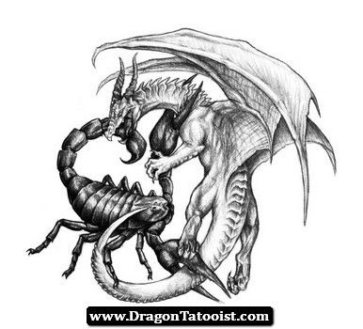

Nythynithis’ previous pain was a love tap. Screeching, the dragon’s serpentine neck reached around attempting to bite its tormentor. The stinger kept piercing and injecting. Fang kept shredding and slicing. Kilzadi had reached the fray. The red dragon’s razor-sharp teeth and fangs easily bit through the deep’s scales. A speedy twist snapped it. A second twist ended Nythynithis’ life. It began its freefall, to splashdown, hundreds of feet down into the valley; the scorpion still latched on and still stinging the now dead dragon.

“No time to admire the view. Time to move on-now!” Gwenect’s voice exhorted them. And so, they continued. Each were silent, wrapped in their own thoughts about what had just occurred. Hours went by. They ate cold, dry rations. They moved on. Hours passed.
-----------------------------------------------------------------------------------------------------------
They came to a smaller side passage branching off into total darkness. Risca felt an urge, an attraction that pulled him in that direction. It was too strong to ignore. He stopped at the intersection and spoke the first words since the dragon encounter.
“Wait! Gwenect, where does that lead to?”

They all halted. “It is the path to guaranteed, unavoidable death” was her response. We need to rest soon. Let us continue.”

“No, wait. Explain yourself. I feel the need to follow that path.”

She sighed at the time waste but expounded. “It is an area avoided by all in the Underdark; by even the most powerful of beings. It eventually leads to a ruined city, a dwarf city, once named Dalvar Hold. The tale states that two millennia ago, the Stoneshaft clan and their allies build a great city there and prospered. So much so that the nearby drow became afraid and grouped together to destroy it. Combining the armies of all their Houses, they made war with the dwarfs. The dwarfs greatly outnumbered, lacking re-enforcements, and out magicked lost. Dalvar Hold was razed. So great was the needless slaughter, it is said that Marthammor Duin himself laid a curse upon the area, a curse that will not allow anything to exist there, not plant or animal, not living or undead, not corporal, or incorporeal. Many have tried, many have, well simply,,,, ceased to exist. Now it is shunned.”

At the mention of his god Risca felt the urge become stronger. “It may be so, but I must go.” He turned to head down the darkened path.

“Hold up Risca!” commanded Gideon. “Gwenect, are you certain?”

“Yes, but…but there is also a saying about the Curse of Dalvar Hold, one swirling the Underdark for centuries, = Cursed who enter, Cease to exist, Unaccompanied by him, the Avenger, the Drow Tormentor, the Axe Grim.”

“Well, I sure hope that Risca is the one in the saying” added Kilzadi, “because he is on his way.” Indeed, Risca was already moving along the side trail. “Gideon?”

There was no hesitation by the priest. “The Seekers always stand together. Follow!”
--------------------------------------------------------------------------------------------------------------
Risca led for an hour. The trail opened into a vast cavern, inside which were the ruins of an immense city. Nothing stirred, not even the tiniest insects. It was deathly still, no sound of any kind. Strewn around for miles were dust covered shattered ancient weapons and armor, broken-down machines of war but surprisingly no bones or remains of any type. The dust seemed to have been undisturbed for a long, long time.
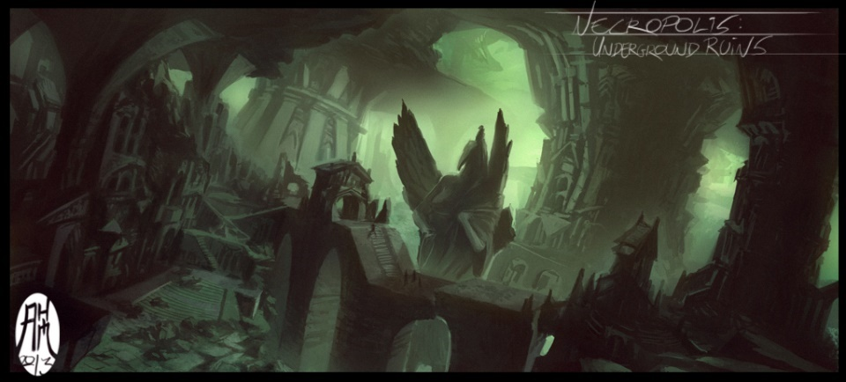
The Ruins of Dalvar Hold
Risca felt a certainty; this had to be done; their success needed it. In the ruins, as if in a distance, he could hear sounds of war, the shouts, the cries, the clash of metal on metal, the blasts of magic, the bellow of battle-beasts. He knew his companions would be safe if they stayed near him. He felt his god leading him by the hand.

They followed Risca into the ruins. The further they travelled, they sensed unshakeable dread surrounding them. Surprisingly, the dwarf appeared to know exactly where to head. “Risca” called out Gideon.

“This needs to be done Gideon. Stay close to avoid the curse. Ignore the noise.” This puzzled the others as all was uncannily silent.

He led them to a wreck, a tumble of wall stones. Wiping away layers of dust, one cracked slab revealed the upright mace symbol of Marthammor Duin carved into it. “Here. Help me lift this.”

Eventually they did to see a crate in the ground. “Risca, what is this?” queried Gideon.

“A weapon of the Stoneshaft clan. Mine now. To use against the Sharrans.” Opening it revealed doll-sized statues of dwarf warriors.

“Dolls. Risca? Your weapon is a bunch of stone dolls?” blurted Neon

“No, Neon. My weapon is a bunch of stone warriors.” He began packing the doll statues.

Gwenect spoke out. “The legend must be correct. You are the Axe-Grim, the drow tormentor.”

“The only drow I torment are those who wish or did ill to me, my people, my friends, my world” replied Risca, continuing to pack the dolls.

“What do you mean, it must be correct?” asked the rogue of the sword dancer.

“I know you feel it Neon, as we all do; that sense of constant dread, that itch of ominous menace that lurks all around us; how it increases the farther we are from Risca. This place is cursed. Without Risca we would all somehow have ‘ceased to exist’. He must be the Axe-Grim of the tale.”

“Then we are safe if we stay near the dwarf. Well, Risca, you are mentioned in legends.” The dwarf just snorted.

Lord No’s Note- Here Neon was referring to the Dalvar Hold curse, but, of course, as my readers know, there are many legends of Risca Foraker; the leader of a great dwarven hold of many clans.

“Apparently so” added Gideon. He addressed the group. “No one go exploring or wander off. We stay close together. Now we need to sleep and regain our strengths. Suggests, Gwenect?”

The sword dancer replied, “Since we are with Risca, this place, because of its curse, is the safest spot. Nothing can disturb us. I say we make camp here. We will not even need watches.”

“Let’s do it Seekers” was the priest’s response.
-----------------------------------------------------------------------------------------------------------------
For the first time since entering the Underdark there was no noise, no annoying insects. After their meal and preparing bedrolls, they fell into little sets.

Neon set up his bedroll beside Risca’s. “With no exaggeration, this is the quietest I have ever been in, without the use of silence spells.”

“Quiet for you Neon, but I hear it, the noise of combat, the roar of monsters, the cries of warriors, the sound of war machines. It is as if I am present in that long-ago battle. I hear it as a direct whisper. The dwarf anguish inspires me to take vengeance on the drow and on my cousin.”

“With me by your side, Risca. With me by your side. But tell me, how did you know to come here?”

“The Watchful Eye led me here.”

“Then we have avenging in common; the difference being mine does not extend centuries into the past. The time of Aleena’s murder and the near murder of Jhaer is much more recent. I vowed to take my vengeance ‘all the way to the top’.”

“I remember. And with me by your side, Neon. With me by your side. What is me gurl up to now?” He indicated towards Swan, putting down her bedroll beside Okul’s.
---------------------------------------------------------------------------------------------------------------------
“Amazing is it not, and surprising, that our Risca is the one to hold the curse at bay. Who would have thought?” Kilzadi addressed Gwenect and Gideon.

Gwenect responded. “It is more remarkable that an ancient curse sustains us tonight, frees us from guarding so that we may be more rested and better prepared for what we will face after tonight. It is as though….”

Gideon finished Gwenect’s statement. “ … as though the dwarven gods prepared for this night more than two millennia ago, just for us here now. Not only a good night’s sleep but also a new weapon.”

She continued. “Yes. a new weapon that gives us more numbers should we be hard-pressed in Maerimydra; construct soldiers, dolls that become full-sized stone golems. A weapon the Stoneshaft clan never used, lying in wait, now Risca’s to command, to use against the Darkness.”

“Maerimydra. Yes, we should plan how to proceed once we reach it.” added Kilzadi. The others nodded. “But first regard something we used to see much of but not for awhile now.”

He indicated Swan, putting down her bedroll beside Okul’s. “At times, she has not been our darling of Deepingdale, more the ‘Punitor Supreme’; passionless. single-minded, and merciless. It all began with the Ashabedford quake, the Night of Dark Tremors. She oscillates hot and cold, and the cause is not external. My magic tells me. So, it must be something she is doing to herself. That implies only she can solve it. It is worrisome but especially for Okul. I fear for my sister, but the poor fool is mad with concern.”

“Of course, he is” replied Gwenect. “We all care for Swan, but she is his amorata. At least her fighting skills have not diminished. If anything, have slightly improved, especially in the shadows. And now she can summon a huge death scorpion. Who knew?”

“Yes, we all worry” added Gideon, “but until this mission is ended, there is no time to determine cause and remedy her behaviour. We will be watchful though. First Maerimydra, then Swan.”
---------------------------------------------------------------------------------------------------------------------
Okul watched Swan approach. To his knowing eyes, she appeared willing but saddened. What he did not know was the just finished conversation between her and her alter ego.

We are us. We are not cruel. Tonight, we are not needed. The Curse guards us and the Seekers. We release us.
I am to surface? In the Underdark? Our agreement…

Lord No’s Note- This agreement is described in Chapter 28.

Until we leave the Curse, we freely release us. We are not cruel. We understand pleasure. Go to him, go to the Bringer of Pleasure.

She knelt her bedroll beside his. “Swan,,,” he began.

“Hush”, putting a finger on his lips. “I know this is hard on you, love, but worry not. Trust me. All will become evident. There is a reason for my errant behaviour. Should I become indifferent to you and the others, it is because there is, inside me, a punitor, its purpose unfinished and with an overwhelming need to see justice done. Will of the gods. All else is subordinate. It establishes itself to ensure nothing blocks it from reaching its objectives. When it dominates, it supresses all other emotions and needs. I behave as a different person, beyond my control. For now. But I will find a way. But it is a temporary condition”. I hope.

We are not ‘it’. We are us. There is no controlled, no controller, just agreement. We learn to be us. Already we begin to use the shadows even shadows hidden in words, to ease our loved ones. No! I do not lie. Harsh word. Instead, we slant the meaning. To pursue vengeance, we stalk, we hunt, and now we misdirect. Justice, not vengeance! At times the two intertwine, inseparable. Please! Not now. I want my time with him. No need for the punitor now. You said so. True. We go.

Her mind quieted. She ran her hand along his neck scales. Something she loved. She continued in the language of dragons. “Vertu mir matei meine, auruk meine, my mate, my gold?”

“Of course I trust you” he replied. “It is just that…”

“Then know you need not worry, none of you. Tonight, I am not punitor. I am your Swan. Hold me, touch me, comfort me. I need this.” Her eyes moistened. “Please, Okul, please, mi amorata,”

He could never refuse her. That night was their last night entwined together until the unification and the emergence of the Shadow Swan That night all the Seekers slept, worry free, to wake refreshed and invigorated.

Lord No’s Note- The emergence of the Shadow Swan is described in ‘The Final Chapter’.
-------------------------------------------------------------------------------------------------------------
The group had travelled several hours. Sounds came from around a bend. Gwenect halted them.

“More of your Underdark creatures?” Neon addressed her.

“Scavengers. Fighting each other.” She tilted her head. “Giant ants, engaging a carrion crawler and some cavvekans.”

“Ants and crawlers I know. But cavvekans?”

“Underdark jackals. The ants will be relentless and will have sent for reinforcements. They are all busy with each other. We should easily pass them.”

It was not to be. Rounding the bend, they saw the combat. They saw the prize that was being fought over. A dozen ants lay paralyzed around the carrion crawler upon which swarmed another dozen; their pincers piercing and tearing away its flesh. A third dozen fended off a quartet of cavvekans as they attempted to rush in and take bites of the prize. The prize was the true horror.
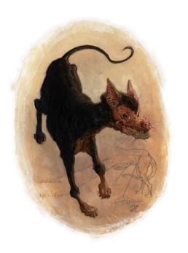 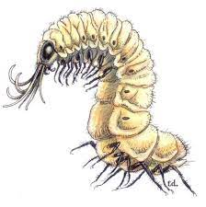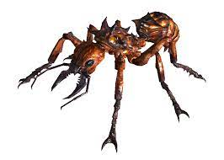 Cavvekan Carrion Crawler Giant Ant

There, in front of them, lay a small heap of random tossed dead dwarfs. Dwarf captives from Glen. Dwarfs too old, too weak, or too sick to keep up the pace.

A barrage of arrows, magic missiles, scorching rays, and physic blasts decimated all the scavengers except two cavvekans who quickly ran off into the darkness.

The Seekers gathered round. Risca foaming, vowed furious vengeance upon the drow and especially upon his cousin.

“We cannot leave the bodies here to be scavenged” spoke up Gideon as they assessed the slaughter.

“They cannot be buried” responded Gwenect. It would take too long. The ground is too hard, and the ants will be back soon. Besides, even should we succeed, the scavengers will eventually dig then out. “Are dwarfs adverse to a fiery funeral?”

“It is not common amongst them. They more intern and…”

“Do it!” interrupted Risca in a spittle spray of enraged words. “None of my kin will be scavenger food.”

“I can empower a fireball”, spoke up Kilzadi, “enough so that even dense dwarf bones will become ash.”

“Do it!” repeated the dwarf. “Do it such that it is delayed, delayed giving more time for scavengers to approach. Catch them in the blast. Surprise them.”

It was then a weak voice from the mound’s bottom came.

“Risca… Risca…., I…hear…you.”

They soon removed the speaker from the pile bottom. They all recognized Mastersmith Thorik of Glen. Beaten, bruised and near death.

“Heal him! Heal him!”

“No…Too late. Forgive me for doubting you Risca. Save the Glen dwarfs, Risca.”

“I will and also avenge them.”

“We will avenge them together. I will be there with you. Use this.”

He gave over a granite figurine depicting an ancient, solemn dwarf dressed for battle and wielding a large warhammer. Thorik muttered a few words. A whitish vapour streamed from his nose into the figurine’s nose. Then a death rattle.

Gideon’s awed voice interrupted Risca’s stare. That is a rare Dwarven Ancestor Figurine. Thorik’s life force now inhabits it. In essence it is powered by Thorik’s will.”

“We must move along. Quickly.” pleaded Gwenect.

Ricsa raised the figurine. “To the Morndinsamman, I will be the promised Axe-Grim. This I vow by all you gods of my fathers. I will avenge both Dalvar’s Hold and Glen Town, the past and the present. Do it now Kilzadi!”

Gideon prayed. “Gods of the dwarven folk. Accept the souls of these, your people, into your halls.”

“Move out” ordered Gwenect. Kilzadi intoned the empowered fireball to delay. The Seekers quick marched away. A half-hour later they could still feel the blast, so powerful it was.

More hours passed. They came across the remains of three drow warriors; only dried-out husks of skin and bones, their innards missing, clothing and equipment still fresh and intact.

“City of Maerimydra, House T’sarran” explained Gwenect, examining the drow insignia. “Dead less than half a day. This warrior was drider bitten, spider-eaten, his insides all sucked out. We are getting closer. Stay alert.”

They all knew about driders, mostly priestesses, who failed Loth’s Test. Their punishment, a large spider body from the waist down, they were shunned and ostracized by drow society. Consequently, they would leave to become dangerous predators of the Underdark. Their failure led to a great sense of shame, giving them a death wish, making them fearless. Keeping all their drow and magic abilities and gaining spider abilities turned them into great threats.

Shortly the passage narrowed and sloped down even as the walls rose higher and steeper to wide ledges on both sides. Three cave openings were visible on each ledge. Running along and across, linking and joining the ledges high above their heads was a mesh of spider webs. Also, dangling, slowly twisting one way and then the other were dead drow warriors wrapped in similar webs.

“What ever attacked the drow is up there” commented Neon. “Its obvious we will be attacked from both sides should we just try to pass through. I say we take the fight to them.”

“Agreed” concurred Gideon. “Okul and Swan to the left, Kilzadi, Fang and Neon to the right. The rest here ready to help and heal as needed. But first accept Kossuth’s aid.”

He prayed “Firelord, I ask you, bless and elate the Seekers as they do your work. Accept my prayer.” The god answered. Kossuth’s grace filled them.

Kilzadi summoned a fire elemental. “The better to burn through webbings.”

Each group was almost to the ledge top when the attack began.
--------------------------------------------------------------------------------------------------------------------

Okul and Dark Swan

Dark Swan was impatient. More delays; delays to her bringing punitor retribution to the Malorns. Okul’s climbing strength kept pace with Swan’s spider boots as he climbed beside her. It allowed him to watch her more closely.

Almost at the top, there was an ear-piercing scream of hate. Emerging from the cave entrances was a drider and another strange creature, later recognized as a web golem.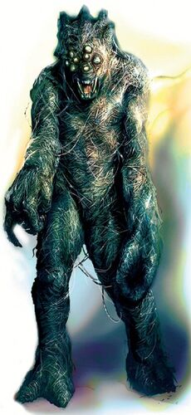

The drider identified the powerful half-dragon as the greater danger and so directed its lightning bolt at him. Just another spellcaster who underestimated the deadliness of the scout and so forfeited its life. The golem shot forth a web, engulfing and immobilizing both Seekers to its sticky strands. Restrained, they could still hear a battle raging on the other side; the thunder clap following the firing of magic lightning bolts, Fang’s roar of rage. The drider prepared to cast magic missile at Okul.

Swan’s shadow cloak teleported her onto the ledge. Okul shook as the lightning struck, hurt but not disposed. Okul’s Great Spear flamed on, burning away the webbing that held him. Despite its size and weight, he hurled it as one would a small javelin.

Granpar’s bow is a mage-killer. Swan’s rapidly shot arrows struck, three in the spider-like body, two in the drow head. The drider could not finish the spell. It was dead. Swan tumbled her way into the caves,

Great Spear lodged itself in the golem’s torso. It burned and burned, its web make-up untangling. Okul reached it, pulled it out, rammed it into the golem’s head The head flame-burst The construct stood still, its body ashing away. Okul retrieved it and ran into the caves.

Inside was pitch-black, total darkness. A high-pitched voice screamed out, the words in drow dialect-“bon nourit. li tue.” Dark Swan had no intention of being anyone’s ‘good food’.

“Solite!” she shouted in return. She became a sun, emitting high noon daylight. Now she could see. Despite three separate entrances, it was only one large cave. Thick strands of spider webs strewn the space, with tens of dried desiccated creature bodies wrapped hither and thither.
From outside came the sounds of Risca battle cry and a fireball’s explosion.

Closest to Swan, stood a web golem; two driders rode the webs further back and farthest away, on the ceiling, were two huge subterranean sword spiders. Even as the driders screeched, dazzled and blinded by the bright light; even as the spiders skittered, Dark Swan dodged the golem, launching arrows. Accurate and deadly, another drider died.

Okul charged, ramming Great Spear into the golem. He was slammed back, ribs cracked. Undaunted, ignoring pain, he again thrust Great Spear into the golem. Now it flamed, burning the golem’s web makeup. He thrust a third time only to be assailed by drider magic missiles. He staggered. He threw Great Spear at the last drider. The weapon passed through the drider, pinning it to the wall. It died as its fluids slipped out.

Dark Swan saw the drider’s demise even as her arrow volleys decimated the remaining spiders. She walked down the wall, returning to the now in-discomfort half dragon. “Swan, are you…”

“We are fine, Bringer of Pleasure, but we note you are not. We will remedy that. You will need full health to rescue your brother. We need you to help punish the Malorns.” She put one hand on each side of his neck. She intoned prayers of healing. For the first time in its existence, the odor of pine and mint, Swan’s signature healing, was present in the Underdark. “Now retrieve your weapon and let us see how fare the others.”
--------------------------------------------------------------------------------------------------------------------
Neon, Kilzadi, and Fang

Fang was about to land on the ledge. The rest were close behind. From the three cave-like openings monstrosities emerged: web golems, a clutch of sword spiders and more dangerous, driders. Some spiders, and golems quickly slithered down to attack the three remaining Seekers. Simultaneously, the driders launched lightning bolts at them, each striking true.

The young dragon roared out his rage! His Weyr was under attack. They dared? He dived at a drider. Spotting the diving dragon, it evoked a barrage of magic missiles. But Fang had learned Master’s lessons well. He had already cast his shield spell. The force magic was absorbed. But nothing could absorb the dragon’s natural body armaments. Claws sinking deep, it bit and slid its burred thorned body along the drider, essentially ripping it to shreds.

Neon was next up. He sidestepped a golem’s casted web and spring attacking, stabbed the short sword named Fireburst into the construct. It exploded into flame. His other hand, holding Blinking Rapier, saved him from a lightning strike of another drider. Then he found himself surrounded by swarming spiders and golems. Suddenly the whole area lit up as bright high noon daylight streamed out of the three cave openings on the opposite ledge. He knew then Swan had released her light The drider screeched and covered its eyes.

As this occurred, the fire elemental and Kilzadi arrived. The elemental just melded itself to a golem. Kilzadi thought that Neon was in immediate very serious danger.

“Neon, use your evasion!” he shouted out as he began to cast.

“No wait. I can blin….” He did not finish due to the fireball exploding.

Everything around him was incinerated; nothing left alive. He evaded best he could, enough to avoid ignition but not enough to be badly burned. He would need healing, lots of healing. He hurt.

“Kilzadi, you idiot” he managed with a wince. I had it under control. Why?”

“You were about to have a horde of spiders chew away every part of your body. I had to do something quickly. And you are good at evading.”

“Good at evading doesn’t mean evade works every time.” Note to self. Never allow Gideon to pair me up with killer mage-boy again.

“It’s done, and we survived. Now let us get you some healing.”

“Well, we agree on something.”
----------------------------------------------------------------------------------------------------------------
Gideon, Risca and Gwenect

They watched as the others climbed up. Both parties were nearly at the top when the monsters emerged amid a fanfare of screeches, squeals, and shrieks. A pack of sword spiders, web golems and a single drider slithered down to engage them.

“Prepare yourselves” ordered Gideon. Just then lightning bolts struck all three. Risca staggered, anger suppressing the hurt. Bugs, bugs, he always got the bugs. They were preventing him from achieving vengeance. Was this how his gurl, as punitor, felt when delayed? Nothing would halt his obligation as the Axe-Grim. Filling with rage and holy fury he charged screaming out his new battle-cry ‘For dwarvenkind!’.

Gideon reeled from the electric pain. Reeled, but still aware. The drider is the most dangerous. He cast and a fiery whip of force appeared over the drider. He prepared his next spell.

Gwenect hurt, her body in shock pain. Even so as a priestess of Ellistraee, her mind was clear. The drider was the most dangerous. She incanted and a bastard sword of force appeared above the drider. Drawing her own moon sword, she began to sing as she danced, leaping, twirling, as she cut and sliced her way through spiders and golems to reach the drider. Balls of moonlight swirled around her, brightening the area as she moon danced, as if an avatar of Ellistraee herself.

Risca shield slammed a spider at the same time Guifoon sundered its head. The spider had managed to slice his arm, but so great was his anger and fury that he did not notice. There was no pain. He charged the next one. “Fur dwarkar!”

The drider set to cast when daylight streamed out of the cave openings. The aberration shrieked, its hands covering its eyes, the spell now lost. It shrieked again as the fiery whip lashed it and the bastard sword stabbed into it. There was the sound of an exploding fireball above them.

Gideon released his spell at the web golem attempting to attack Gwenect, blocking her path to the drider. His searing ray burned through it, igniting it. The threat was removed. A mental command moved the fiery whip to the next one.

Gwenect reached the drider. Her song reaching a crescendo, one last twirl added impetus to the sword swing. The moon sword decapitated the drider, freeing the once female drow from the Curse of Loth. She now danced and sang her way to the spiders engaging Risca, the bastard sword following her.

Risca found himself confronting the last two spiders. Three, he had already eliminated. His body had suffered several deep slashes and he had been bitten once. The poison was slowing him down. Yet, he fought on, how could he not? He was Risca Foraker, the dwarf who spits in the face of dragons, the dwarf who threatens to tear down temples. He was the Axe-Grim! Through his rage and fury, he could hear a faint song; one whose notes reminded him of the beauty of moon-filled skies over the snow-capped mountains of his dwarven home. As the music got louder, the moonlight got brighter. The poison effects were slowing as if delayed. He felt refreshed. Then the sword dancer was beside him.

They fought as a team, the dwarf hell reaver and the drow ranger. When one blocked with shield and axe, the other stabbed and slashed with sword. When one feinted with sword and steps, the other hacked and slashed with axe. To this add the bastard sword of force continuing to stab again and again, the spiders were soon slain.

The web golem launched its web at the priest even though the fiery whip had lashed it several times. Gideon had no more searing rays. Instead, the web and golem were met by a psionic blast. The web was disintegrated, and the golem was knocked back. A second blast destroyed it. Just as good, just takes a little longer. Now let’s check the others.
………………………………………………………………………………………………….
The Seekers were back together. All had been healed. The drider/spider lairs had been cleaned out.

“It is time to continue” stated Gideon. We are close to our destination. Keep alert. Same marching order. Gwenect, lead us out.”

And so they set off once again, each with a purpose to fulfill once they arrived at Maerimydra.

……………………………………………………………………..to be continued

